Critical Eye
Final Paper
Susan Carlson
Spring 2019
Carlos Becerra

Photography is interesting in that it captures a specific space within a particular moment in time. These two-dimensional representations of three-dimensional space are generally what we understand to be photographs. Successful and compelling photographs often lead you into the scene and give you a sense that you are there and present in the photographed space; however, what if you could actually feel as if you’re seeing what the photographer saw, with your own two eyes? In an ordinary photograph, it is impossible to perceive any genuine sensation of depth or to convey a complete sense of the solidity of objects. Stereo photography accomplishes this by reproducing more or less exactly the phenomenon of binocular vision, and is potentially one of the most important technological applications of photography since its invention.

Stereo photography is by no means new and has evolved alongside photography, in fact, the Wheatstone stereoscope, which is the first device invented for viewing a pair of stereoscopic (left and right eye) images was invented in 1838, this precedes the invention of the first practical photographic process, the daguerreotype, which was first introduced in 1839. The stereo daguerreotypes that were made mostly showcased statues, still life’s and people. A lot of portraits, and surprisingly nude or pornographic stereo daguerreotypes were predominant during stereo photography’s initial boom. This medium first gained popularity after David Brewster improved upon the design of the stereoscope reducing it in size and making a handheld model, Queen Victoria admired this device when it was on display at the great exhibition of 1851. Following this event, almost overnight, a 3D industry developed and 250,000 stereoscopes were produced and a great number of stereoviews, stereo cards, stereo pairs or stereographs were sold in a short time. Stereographers were sent throughout the world to capture views for the new medium and feed the demand for 3D.

Stereo was used for a wide variety of things, historical photos, landscapes, portraits, family photos, tourist photos and many other uses. Some of these take advantage of the added depth and visual perception of three dimensions more than others. The majority of the stereo daguerreotypes were predominantly of nudes and pornographic images, which is interesting, now, many of these have sold at auctions for thousands of dollars. I have included and will discuss two stereo daguerreotypes, both of which are hand tinted. The first image (see figure 1) taken by Antoine Claudet is of a mother and daughter in a studio setting. They are posed on a couch dressed quite elegantly and the mother is wearing a flowing violet skirt. There is a clear sense of intimacy as the child is posed quite close to her mother’s face. They are at the foreground of the photo along with a small statue towards the right side of the frame which aids in creating depth. In the midground there is a piano that leads you from the foreground to the background and in the background, there is a curtained window with a view of a landscape and blue sky outside the window, additionally the patterned wallpaper gives a distinguished texture and readability to the background. The second stereo daguerreotype (see figure 2) is of a nude female, her arms are stretched over head and she is holding a tambourine in her hands, she is quite clearly the central focus of the image as she takes up the majority of the frame, aside from a pair of curtains behind her on the left and right sides. This image evokes a sense of eroticism and the “exotic” which was very common as in this era a lot of the bourgeoise that could afford daguerreotypes were obsessed with all things “foreign and oriental”. One thing that both of images have in common is that they are very personal and not meant to be exhibited to a broader audience, especially the fact that they are stereo images means they are meant to be viewed by a single person at any given time.

Following the daguerreotype process, the next most common application of stereo photography was stereo cards, these were made by placing two prints made from the two slightly different negatives side by side, most commonly these prints were albumen prints and then later gelatin silver prints. These stereo cards were often reproduced and distributed to a wider audience, unlike the stereo daguerreotypes which were all one of a kind. The subject matter of the stereo cards ranges vastly, however they often focus on landscapes and recording people, places and events in a historical or documentary fashion.

There are three stereo cards which I have chosen that I believe embody this notion. “Gazing Into a Yawning Chasm 5,000 feet deep” – 1903 (see figure 3) depicts a woman in a dress and hat at the grand canyon she stands at the foreground at the bottom left of the frame at the edge of a ledge and staring down into the abyss. On the right side of the frame there is another ridge which is situated spatially in the midground, in the background the Grand Canyon stretches out towards the horizon, as far as the eye can see. In this image, the landscape and human presence within the American Landscape is predominantly what is being placed on display. This is a common theme not only of stereo photography but of landscape photography in general in the time period this photo was created. The second image “Wreck of a Lumber Schooner” – 1903 (see figure 4) contains an abundance of visual elements that help elevate the stereo effect of the photo. One of the main elements is that there are a lot of diagonals, which are commonly used in drawing or painting to create depth, however in this stereoscopic medium the diagonals really aid in the appreciation of the dimensionality of the photographed space. Additionally, there are several layers which amplify the stereo card. The foreground can broken up into 5 parts: the pattern in the sand, at the very bottom of the frame, the rope stretching diagonally from the left to the right of the frame, the man standing on the left side of the frame, the pieces of wood lined up going across the frame behind the man and finally the group of three people; man, woman and child standing together on the right hand side of the frame. A pool of water lies in the midground and leads the eyes from the foreground to the background where the wreckage of the ship and a group of men are congregated. The last stereo card I want to include is “The Stereograph as an Educator” – 1901 (see figure 5). This last image is one that is self-reflective on the medium itself, and in a way serves as propaganda or as a means to validate the importance or necessity of the medium.
In 1936, the introduction of transparency film or slide film, caused a resurgence in the use of stereo photography. This film, paired with cameras which were created specifically for taking stereo photographs created a new trend in popularity of stereo photography. After these advances, stereo photography became more widely available to an amateur audience and it once again became a craze similarly to when this medium first came into fruition. The question remains now, what use can stereo photography have in the age of digital media. With the development of Virtual Reality, Augmented Reality and other media which aim to transport you into a different space or change the space you currently inhabit, can stereo photography still remain relevant. I believe it can, and I believe that as long as people can continue to be amazed and mystified when viewing stereo photography in any of its outputs, whether that be stereo cards, stereo prints, stereo slides or even stereo projections, then stereo photography can still impact and alter the way we see and perceive the spaces which we inhabit.

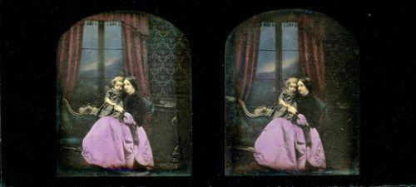

Figure 1. Hand Tinted Stereo Daguerreotype of mother and Child
https://www.icollector.com/MOTHER-CHILD-STEREO-DAGUERREOTYPE-CLAUDET_i5389212

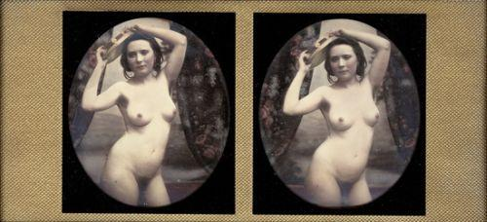

Figure 2. Hand Tinted Nude Stereo Daguerreotype
https://www.icollector.com/NUDE-TAMBOURINE-STEREO-DAGUERREOTYPE_i5389213

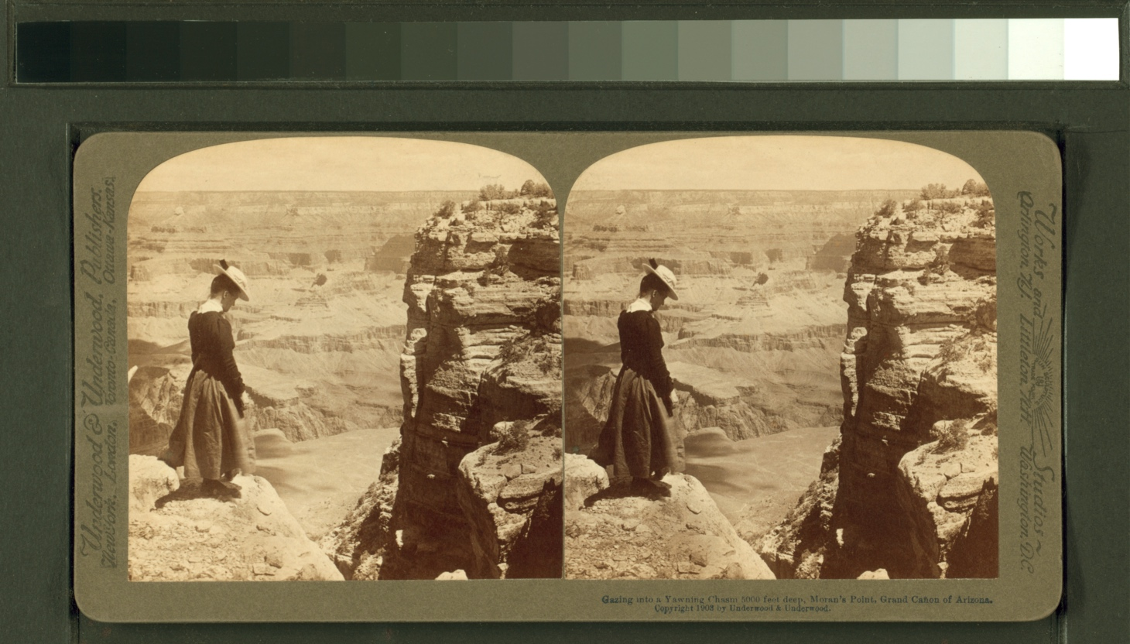
Figure 3. The Miriam and Ira D. Wallach Division of Art, Prints and Photographs: Photography Collection, The New York Public Library. "Gazing into a yawning chasm 5000 feet deep, Moran's Point." New York Public Library Digital Collections. Accessed April 22, 2019. http://digitalcollections.nypl.org/items/510d47df-a45f-a3d9-e040-e00a18064a99

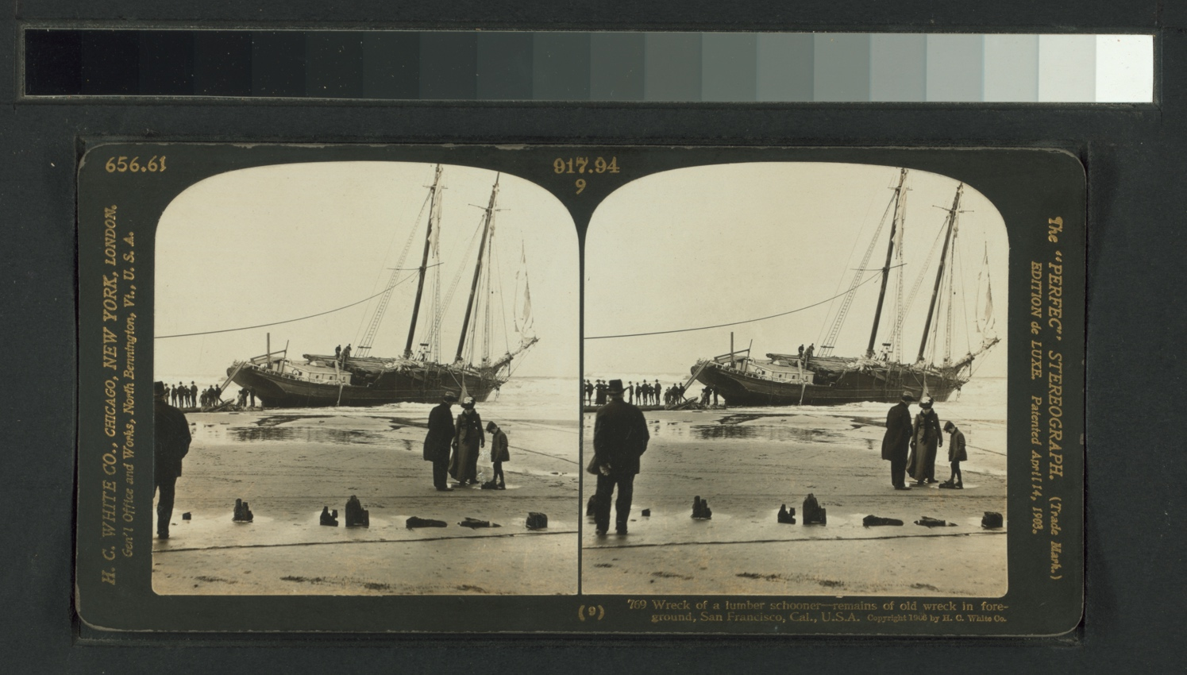
Figure 4. The Miriam and Ira D. Wallach Division of Art, Prints and Photographs: Photography Collection, The New York Public Library. “Wreck of a lumber schooner. Remains of old wreck in foreground, San Francisco, Cal.” New York Public Library Digital Collections. Accessed April 22, 2019. http://digitalcollections.nypl.org/items/510d47e0-4195-a3d9-e040-e00a18064a99
Figure 5. New York : Underwood & Underwood, c1901 March 22. “The stereograph as an educator - Underwood patent extension cabinet in a home library” Library of Congress Prints and Photographs Division Washington, D.C.. Accessed April 22, 2019. http://www.loc.gov/pictures/item/2003674057/

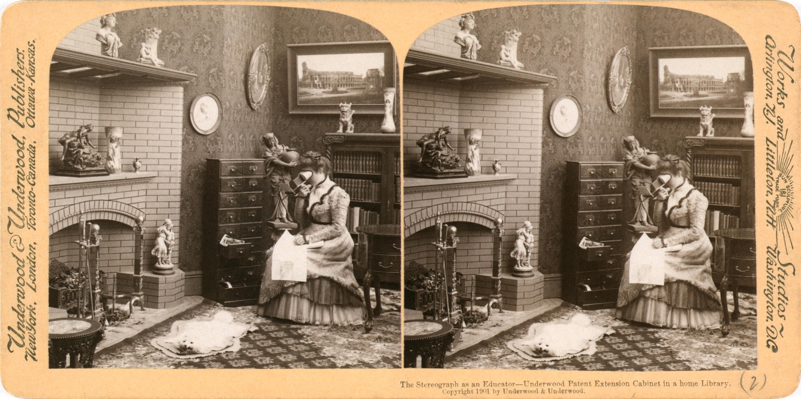

Bibliography
Gowland, Peter. The art and technique of stereo photography. New York: Crown Publishers, 1954.

Symons, K. C. M. (Kenneth Claude Michael). Stereo photography; the technique of the third dimension. London, New York: Focal Press, 1957.

Welling, William. Photography in America The Formative Years, 1839-1900. New York: Thomas Y. Crowell Company. 1978.

Stafford, Barbara; Terpak, Frances and Poggi, Isotta. Devices of Wonder: From the World in a Box to Images on a Screen. Los Angeles: Getty Publications. 2001

Sydney University Museums. The Origins of Stereoscopy. Virtual Empire. Retrieved 22 April 2019.

